Assessment Cover Sheet
Complete and attach this cover sheet to your assessment before submitting
Assessment Title
Project (Traffic Light Simulator) (30%)

Bachelor of Engineering Technology
Programme Title:
ENB5000
Course No.:

Electrical Fundamentals

Course Title:
Zainab Ali
Student Name:
201300423
Student ID:
Ramani Panda
Tutors:
8 January 2015

Due Date: Date submitted:
By submitting this assessment for marking, either electronically or as hard copy, I confirm the following:
This assignment is my own work
Any information used has been properly referenced.
I understand that a copy of my work may be used for moderation.
I have kept a copy of this assignment

Abstract
This project is about constructing and simulating a traffic light circuit. By building the prototype circuit on a breadboard and using altium designer to draw the traffic light circuit diagram and design the PCB board. After that, constructing the electronic components on the PCB board. In this report the electronics components used in the circuit will be verified. The functioning of the traffic light will be discussed showing the difficulties and obstacles faced.

Table of Contents
Abstract 2
List of tables and figures 3
Objectives 4
Introduction 4
Transformer Testing 4
Breadboard prototype 4
Circuit Diagram 5
PCB Diagram 6
Simulation 7
Components 7
Discussion session 8
Conclusions 8
References sections 9

List of tables and figures
Figure 1 5
Figure 2 5
Figure 3 5
Figure 4 - Circuit Diagram 6
Figure 5 - PCB Diagram 6
Figure 6 - PCB 3D Diagram 7
Figure 7 - Soldering 7
Figure 8 - PCB Board 7
Figure 9 - Simulation 8

Table 1 – Components 7
Table 2 - Experiment 8
Table 3 - Simulation 8

Objectives
The main objective of this project is to create a traffic light circuit on a printed circuit board. Building and testing a circuit on a breadboard based on the circuit diagram, drawing and simulating the circuit by using altium design are required too. Assembling the right components and testing them is important.

Introduction
Initially a breadboard was used to test the components and how they function later on the circuit was designed on altium designer software for simulation and in order to produce a PCB. Once the PCB was printed the components were added on and then soldered, eventually the circuit was connected to a power supply of 9V where it worked as required.

Transformer Testing

Breadboard prototype

To create a traffic light circuit producing a components list is needed as a first step. Based on the traffic light circuit, building the circuit on the breadboard and testing it was my next step.
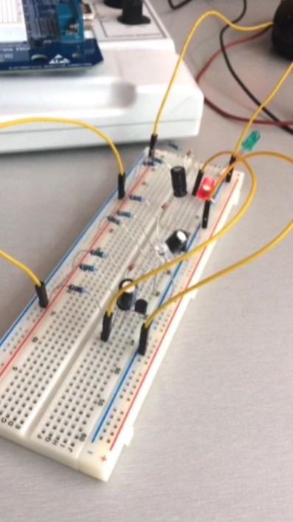
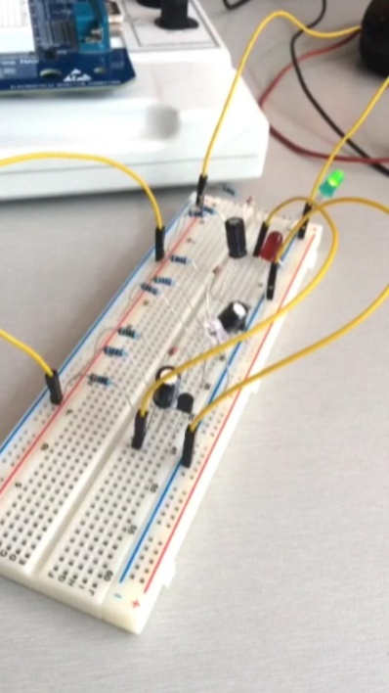
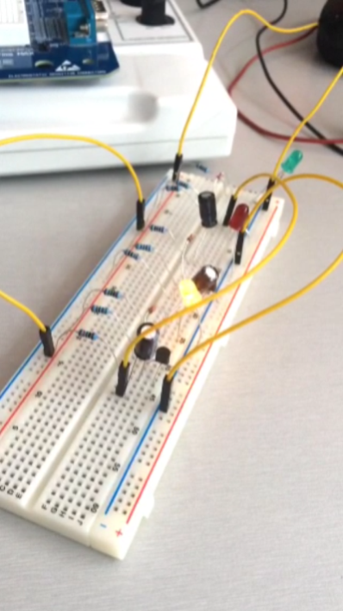
Figure 1
Figure 2
Figure 3

the red led is the first to light on then it turns off and the green led lights on and turns off then the yellow one and so on.
The concept of the circuit idea is :
- The current flows in the circuit and charges the capacitors.
- When the capacitor is fully charged it begins to discharging because of the transistor that is connected to it.
- The transistor switches on and allow the current to flow into the LED consequently the LED turns on.
- The time period of the LED to turn on relies on the discharge of the capacitor into the transistor.
- When a transistor switches off the current will stop flowing to the LED and it will light off as well.
- As a protection for the circuit diodes are used to stop the flow of current to the LED during the transistor is switched on which create an open circuit.

After that, the circuit diagram was created and simulated then created a design for the PCB by using altium designer. The electronic components were replaced from the breadboard to the printed circuit board. And they are soldered to the printed circuit board by using soldering machine.

Circuit Diagram
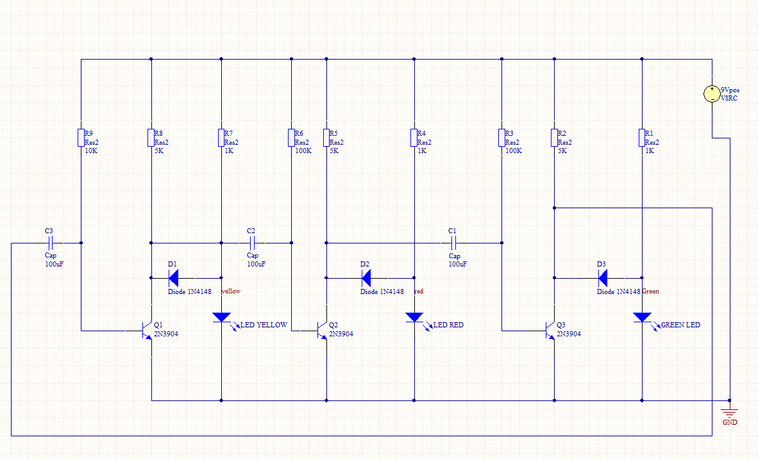
After the breadboard prototype, the circuit diagram has been designed by using altium designer
Figure 4 - Circuit Diagram

PCB Diagram
A design for the PCB has been created by using altium designer software and then printed on a PCB board.
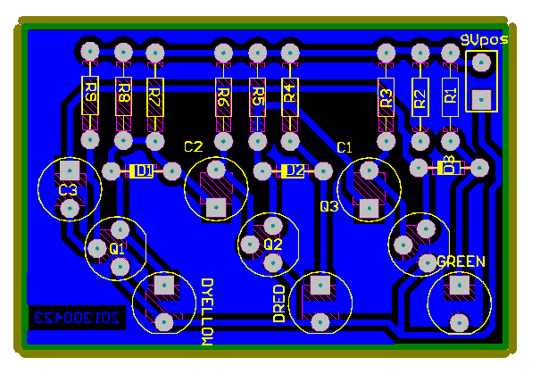
Figure 5 - PCB Diagram

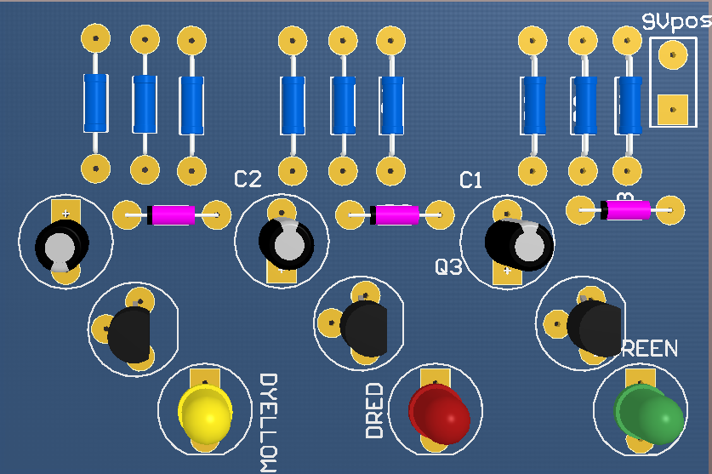
Figure 6 - PCB 3D Diagram
The electronic components were replaced from the breadboard to the printed circuit board. And they are soldered to the printed circuit board by using soldering machine.
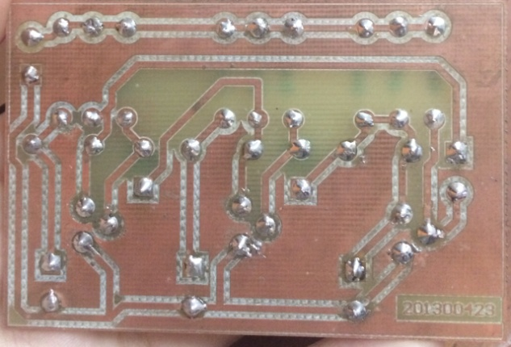
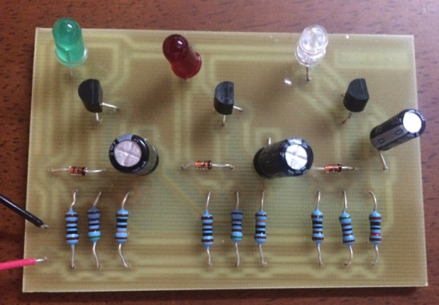
Figure 7 - Soldering
Figure 8 - PCB Board

Simulation
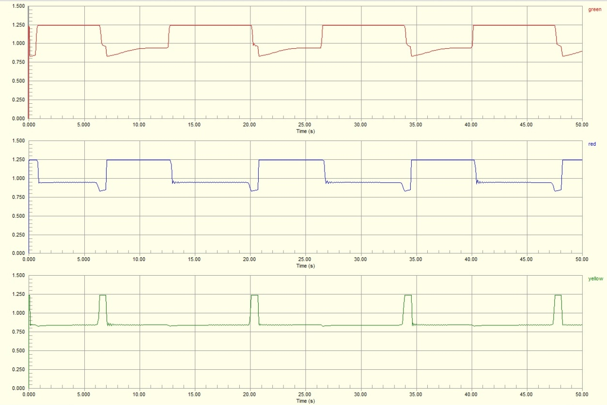
The simulation has been done by using the altium design and it presents the LEDs (red, green and yellow) when they light on and off.
Figure 9 - Simulation

Components
Table 1 – Components
Quantity | Component | Type
3 | Transistors | 2N3904
1 | Resistor | 10K
3 | Resistors | 5K
3 | Resistors | 1K
2 | Resistors | 100K
3 | Capacitors | 100uf
3 | Diodes | 1N4148
3 | LEDs (Light-emitting Diodes) | Red , yellow and green

Discussion session
After building the circuit on the breadboard measurements (time period of the LED when it lights on and voltage across each LEDs) had been taken by the multi-meter. The power supply in the circuit was 9v
Table 2 - Experiment
LEDs | Time | Volt
Red | 1.9s | 1.7v
Green | 1.9s | 1.9v
Yellow | 0.6s | 1.9v

Table 3 - Simulation
LEDs | Time | Volt
Red | 6s | 1.25v
Green | 6s | 1.25v
Yellow | 1s | 1.25v

And the measurements of the experiment is similar to the simulation on altium designer which designates success of both.
To improve this project is to make the traffic light as the real one, the red LED light first then the yellow LED after that the green LED. Moreover the period of time of each light stays on should be longer because if the actual one was used as a real traffic light the car will not have enough time to move. To do that we have to increase the capacitance or the resistance.
The most difficulty I faced was soldering and putting the transistors in the right way. Another thing, designing the PCB and having errors in the simulation were challenging.
I enjoyed designing the PCB board and soldering though they were not easy.

Conclusions
The project was successful. The objectives were accomplished. The circuit had been built on a breadboard then PCB board by replacing the electronic components and soldering them to improve the success of the traffic light.

References sections
Resistor Color Codes. (2000, 03 19). Retrieved from http://www.aikenamps.com/ResistorColorCode.htm

