Assessment Cover Sheet
Complete and attach this cover sheet to your assessment before submitting
Assessment Title
Workshop Report

ENB5990 / ENA 4001 / ENA 5001 level 5

Bachelor of Engineering Technology
Programme Title:

Course No.:
Course Title:

Engineering Practice / English Communication for Engineering 1

Zainab Abdulrahman Hasan Mohamed Ali
Student Name:
201300423
Student ID:
John Donald
Tutors:

Due Date: Date submitted:
By submitting this assessment for marking, either electronically or as hard copy, I confirm the following:
This assignment is my own work
Any information used has been properly referenced.
I understand that a copy of my work may be used for moderation.
I have kept a copy of this assignment

Learning Outcomes
On successful completion of this course, students will be able to-
Apply workshop safety procedures
Interpret basic engineering drawings and use appropriate measuring equipment to manufacture components to a specified tolerance
Manufacture basic engineering components using machinery including-
Hand tools
Hand power tools
Lathes
Milling machines
Welding equipment

Table of Contents
Assessment Cover Sheet 1
Introduction 3
Tools/ Equipment Used 4
Machining procedures 5
Results 9
Comments/Conclusions 10
Bibliography 10
Appendix 10

Introduction
The aim of this report is to describe the overall machining processes done to manufacturing a steam engine. The steam engine consists of eight components:
- Base plate.
The base plate is connected to the main frame and it balances the main frame vertically.
- Main frame.
Basically the use of main frame is to hold all components together and its responsible in the functioning of the steam engine as it controls the air movement between the other components. The height of main frame is 75mm and the height 125.
- Cylinder.
Responsible of receiving the pressurized air and so responsible of the piston movement
- Piston.
Is connected to the crank pin and when the piston moves the crank pin will also move.
- Crank pin.
When the crank pin moves the crank wheel will also move which will lead to rotating the fly wheel.
- Fly wheel.
Controls the energy of the steam engine
We can use this to connect to other applications when needed.
- Crank wheel.
Crank wheel holds the crank pin and main shaft.
- Main shaft.
The use of the main shaft is to connect the crank wheel and the fly wheel through the main frame.
With attention to the all the machines that must used to manufacturing all these components such as: center lathe, milling drill, pillar drill, and mini mill. Consequently, I gained and learned lots of things like interpreting engineering skills, how to use the lathes efficiency and safely by following the steps and the safety rules, how to be accurate in measuring the instruments which means being aware of the difference that one millimeter can make. Furthermore, from this workshop I have gained experience and a clear information about how work looks like in the mechanical workshop.

Tools/ Equipment Used

- Measuring tools
- Rule
- The micrometer caliper
- Digital vernier caliper
- Height vernier plate

- Power machines
- Center lathe contains:
- Headstock contains (spindle with chuck)
- Tailstock contains (ram, ram lock, tailstock lever, hand wheel and dead center)
- Tool post
- Y-axis handwheel
- X-axis handwheel
- Quill
- Coolant pump motor
- Table traverse handle
- Swivel
- Spindle
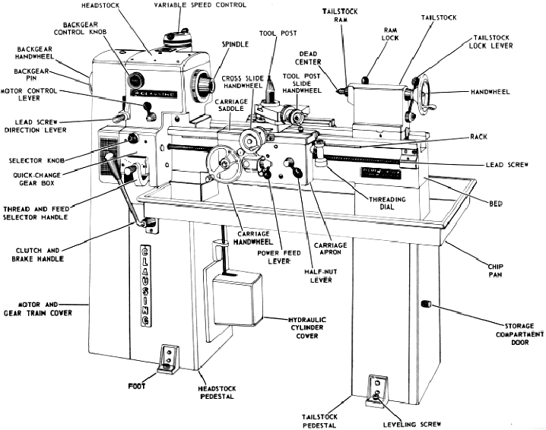
Figure 1 - The centre lathe parts (lathes)

- Vertical a bridge part milling machine contains:
- Variable speed control
- Headstock
- Spindle
- Drill chuck
- Table
- Saddle
- Column
- Work table
- Motor
- Y-axis handwheel
- X-axis handwheel
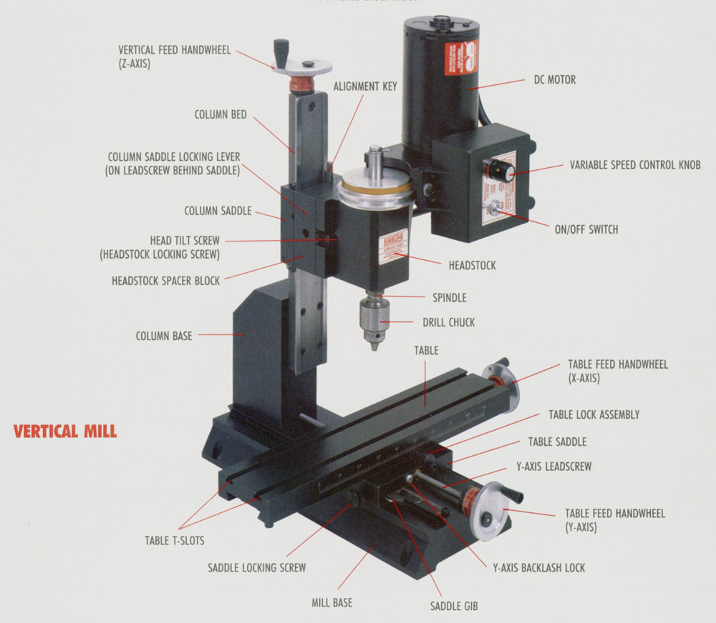
Figure 2 - The parts of milling machine (Miling machine terminology, 2007)
- Mini mill that contains:
- rotary table
- Pillar drill that contains:
- Saddle
- Cross-slide
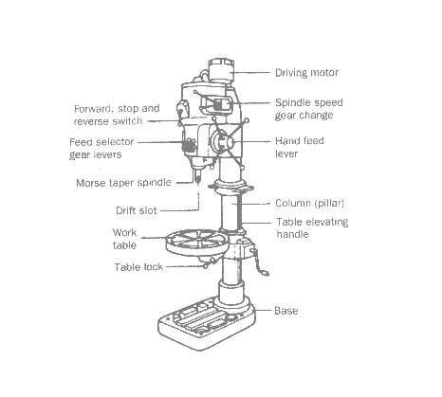
Figure 3 - The pillar drills parts (beardmore, 2013)
- Other general tools
- Odd leg caliper
- Hammer
- Mallet
- Hacksaw
- Center punch
- Files
- Bench vice
- Angle plate
- V-block
- Polishing wheel
- Slot mill
- Blue spray
- Drill bits
- Parting off tool
- Centre drill
- 12mm tapping drill
- CKS
- Reamers
- 4 flute end mill
- Surface table
- Wooden dowel
- Hand wrench
- Chamfering tool
- Shim
- Bolt
- The hardened steal square
- Half round scarper
- Sand papers
- Parallel bars
- Power hand drill
- Jigs
A jig is a tool that holds the work-piece and leads the cutting tool in a machining process such as tapping, reaming or drilling. There are two general sorts of open jigs and boxed jigs. We used open jigs only like a rotary table. Equally important, jigs can benefit us to have a more efficient results. In the workshop for drilling and grooving.

- Cutting materials

Cutting material | Advantages | Disadvantages | Relative Differences
Tungsten Carbide | - Sharp and tough material  - Gives efficiency in cutting  - Produce a clean and straight cuts  - Most versatile cutting material  - Has a long life  - High shock resistance | - Limited speed capabilities | - Longevity  - Ability to sharpened again  - More expensive
HSS  (High Speed Steel) | - Good toughness and strength, over temperature range  - Versatility  - Superior resistance | - Poor speed capabilities  - Poor wear resistance | - Disability to sharpened again  - cheaper

Machining procedures

Before you start any machining procedures you should be aware of your safety in the workshop
- Wear covered or safety shoes.
- Never leave the chuck key in the chuck.
- Wear the safety glasses.
- Never leave the machine open

- Main frame
To produce a main frame you have to do the following steps:
- You must have a rectangular cube piece of aluminum that the width of it is 15mm, the height is more than 75mm and the length is more than 125mm, the milling machine will cut the extra millimeters in the height and the width so the length and the height will be fit to 125mm and 75.
- Make sure the vise and the worktable in the milling machine is clean.
- Measure the height of your piece and let us say it is 80mm
- Place clean parallels bars in the vise and place your piece above them then tighten the jaws and knock the piece with the mallet. Figure 4
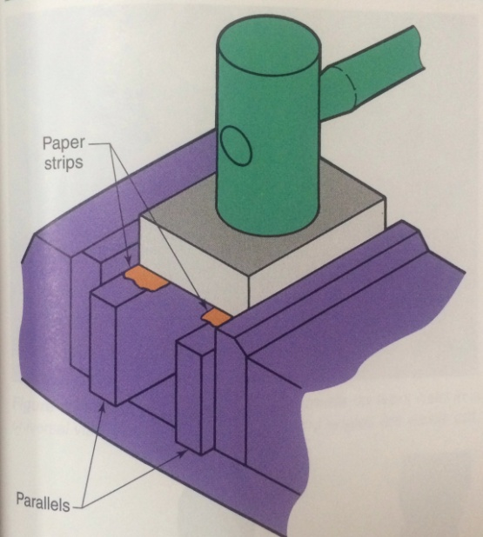
Figure 4 (Walker, 2004)
- Rotate the handwheel of y-axis until your piece becomes parallel with the milling cutter.
- Turn the machine on and start rotating the handwheel of x-axis until the milling cutter touches your piece. And this is called touching on.
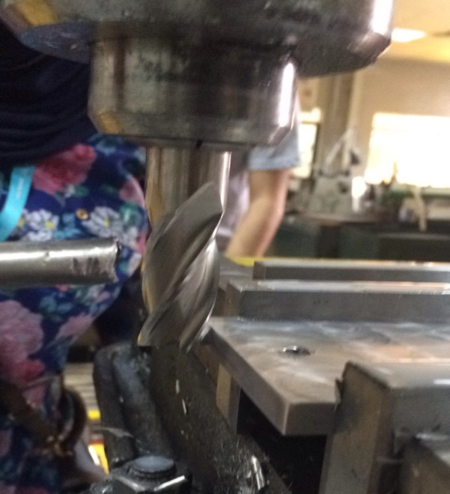
Figure 5
- Stop the machine and set the handwheel of x-axis to zero.
- Rotate the handwheel of x-axis until your piece becomes a little bit away from the milling cutter.
- Turn the machine on and rotate the wheel to one millimeter.
- After you remove one millimeter stop the machine to measure your piece and never forget to stop the machine before you attempt to make measurement.
- Take your piece out and place it in the fitting vise.
- Deburr the side that you cut by the milling machine by file, because the milling machine makes the sides sharp. Consequently, we have to deburr it and make sure you handle your piece carefully so you don’t hurt your hand from the sharp edges.
- Measure the height of your piece and it should become 79 mm.
- Do step 4 again but flip your piece so you cut the other side of your piece.
- Do step 5 if its needed, step 6, 7,8 and 9 until you remove 4 millimeters.
- To be more accurate measure the height of your piece every time you remove 1 millimeter.
- Do the same steps ( 2 to 16 ) for the length
- The length must be 125 mm
After you are done with these steps and you got the fit size which is (height:75mm,length:125mm, width:15mm). You will have to drill holes by completing the following steps:
- Paint your piece by a color spray and wait until it dries.
- Place your piece vertically (so you see the height 75mm) with the right angle surface plate.
- Set the height vernier into 57mm (make sure it is zero when the measuring jaw touches the table) then draw a line by moving the height vernier.
- Make sure that your piece is stable while you draw the line.
- Set the height vernier into 33.75mm and draw another line.
- Do the same thing to draw two other lines (lines heights: 29.98mm and 25mm)
- Place your piece horizontally (so you see the height 125mm).
- Draw 4 lines height( 25mm, 67.91mm, 70.07,)
- Set your piece in a way that you see the height 15mm and the width 125)
- Draw a center horizontal line (height 7.5 mm)
- Flip the piece so you see the height 125mm and the width 15mm
- Draw two lines height ( 25 mm and 100 mm)
- Punch all the intersection points with the center punch
- Place your piece in the fitting vise before you do step 31
- Place your piece in the vise and measure the diameters of drill bits you have by a micrometer or digital vernier caliper
- Put the 3mm drill bit in the chuck make sure you put the drill bit stably
- Drill the pilot hole that is usually 3mm drill bit
- Lock the chuck by the chuck key and never forget the chuck key in the chuck for your safety.
- Adjust the setting of the y-axis and x-axis so the drill bit is perpendicular on the center point.
- Look at the drawing and drill the same place and size of holes that shown in the drawing
- For 6mm diameter you have to start drilling with 3mm drill bit then 5.5 mm drill bit then 6 mm reamer.
- For not all the way through holes, touch the drill bit with your piece while the machine is still off set the depth size you need. (you are going to do this step for three holes two are in the side of your piece and the depth of them should be 12mm, the depth of the third hole should be 7.5 mm
- Your main frame is done
- Fly wheel
To manufacture a fly wheel you have to do the following steps:
- You must have a cylinder piece of aluminum that the diameter of the base is more than 50mm and the height is more than 20mm let us assume the diameter of the base is 55 and the height 80mm
- Place your work piece in the chuck of the center lathe steadily then lock the chuck by the chuck key.
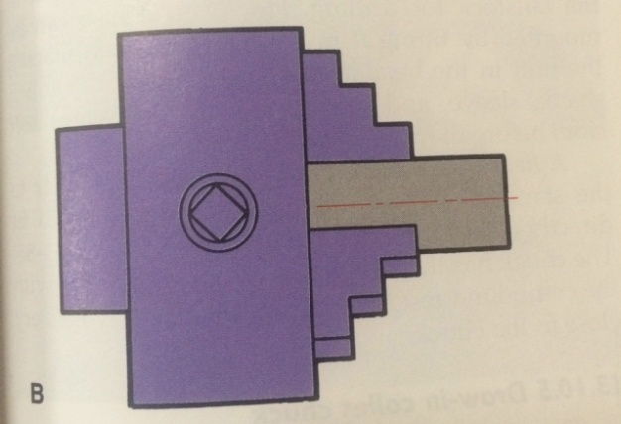
Figure 6 (Walker, 2004)
- Never leave the chuck in the chuck key.
- Place your cutting tool in the tool-post
- Don’t forget to lock the carriage tool-post
- Make sure the cutting tool is in the center.
- Set the speed into 1200 rpm
- If the tool-post is close to your piece move it away by rotating the handwheel of the x-axis.
- Turn the machine on and rotate the handwheel of x-axis until it touches your piece
- Stop the machine and set the handwheel of x-axis to zero
- Rotate the handwheel of x-axis 1mm
- rotate the handwheel of y-axis to your side.
- Start the machine and face off the front. Particularly, rotate the handwheel y-axis until you reach the end of the radius.
- Stop the machine when you finish.
- Widen the odd leg caliper more than 20mm and let us assume you make the wide 23mm
- Open the machine and place the odd leg in the front of your workpiece and let the other leg of the caliper scribe the line of the size of wide you set which is 23mm
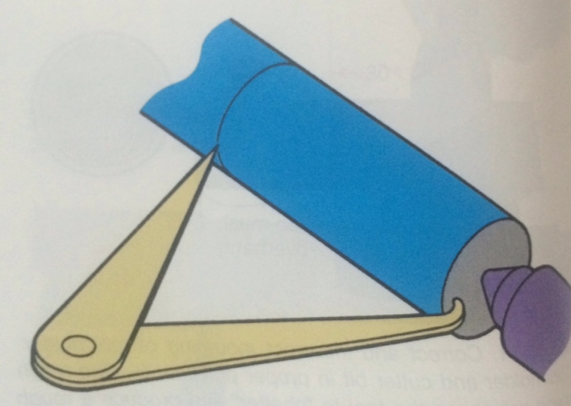
Figure 7 (Walker, 2004)

- Hold the odd leg caliper tightly and be careful not to drop it from your hand.
- After you finish marking the line of the wanted size by the odd leg caliper don’t forget to stop the machine.
The diameter of your work piece is 55mm and it must be 50mm so you have to reduce it 5mm by finishing cuts.
- Rotate the hand-wheel of x-axis to your piece and when the cutter touches your piece then rotate the handwheel of y-axis so the tool-post comes to your side a few millimeters.
- Open the machine and rotate the handwheel y-axis until you touch your piece set the handwheel of y-axis to zero then rotate it to 1mm and start rotating the handwheel of x-axis slowly till you reach the line you drew by the odd leg caliper.
- Stop the machine and take your piece out
- Measure the diameter by the digital vernier
- Do step 20,21,22 untill you get the wanted size which is 50mm
Now you have to part off the unwanted millimeters in the height by the roughing cuts. The following steps bellow can teach you how:
- Place the cutting tool which is designed to part-off
- Make sure the cutting tool is fit in the center
- Don’t forget to lock the carriage in the tool-post
- Rotate the handwheel of x-axis until the cutting tool reach the line you drew by the odd leg caliper
- Turn the machine on and start cutting by rotating the y –axis handwheel
- Cut few millimeters of the depth then rotate the y-axis handwheel the opposite side until the cutter comes out from your piece then rotate the handwheel of x-axis few millimeters to make the cutter tool goes the left side then do the same thing but for the right side (the point of this step is to widen the hole or the depth so the work becomes more safe
- Do step 28 and 29 until your piece fall down .
- When you finish and your piece fell down. Stop the machine and take the piece that fell.
- Measure the diameter of your piece
- place it in the chuck (the side that you didn’t work on it)
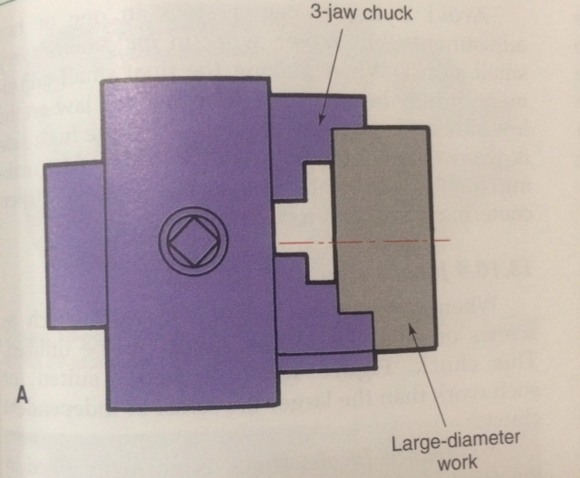
Figure 8
- Do the steps 3 to 14 and measure the diameter of your piece and keep doing the steps then measuring until you get the wanted size which is 20m.
After you finish and you got the wanted sizes (diameter 50mm and height 20mm) you have to drill 6mm hole in the center by the same machine (center lathe).
- Stick a thin paper around your piece before you place it in the chuck so nothing bad happen to your piece.
- Leave a gap above so you can easily measure your piece.
- Replace the tailstock center with the drill chuck
- Place a center drill in the chuck drill and
- Don’t forget to lock the chuck and to not leave the chuck key in the chuck.
- Turn the machine on and drill a center hole by rotating the handwheel of x-axis in the tailstock or it is called a countersink hole which is similar to the center punch
Figure 9 (drilling withing the center lathe, 2003)
- Place 3mm drill in drill chuck then do step 39 and drill all the way through hole
- Stop the machine
- Place 5.5mm drill in the drill chuck then do step 39 and drill all the way through
- Stop the machine
- Place 6mm reamer in the drill chuck then do step 39 and drill all the way through hole
- Turn the machine off
Your flywheel is almost done after you done the 46 steps you have to do grooving 5mm depth and drilling six holes by a mini mill with a rotary table by the following steps:
- Place your piece in the rotary table and lock it
- Turn the machine on and let the cutting tool touches your work piece and set y-axis to zero
- Remove 0. 5 mm for each round until you reach 5mm
After you are done with grooving you have to drill six hole because it is a circle and the angle of the circle is 360 degree so the space between each hole and the other will be 360 /6= 60 degree
- Drill the first hole in 0 degree move 60 degrees to drill the next hole until you reach the 6th hole.
- Wait a few minutes before you take your workpiece from the rotary table because it might be too hot.
- You are done manufacturing a fly wheel
- Cylinder bore
To produce a cylinder you follow the bellow steps:
- You must have rectangular cube piece of aluminum the dimension of the cube should be more than 25mm, more than 57mm and more than 15mm.
- Let us assume that your piece dimensions are 30mm, 60mm and 15mm
Obviously, you have to cut the extra millimeters in the width and the length by the milling machine:
- Do step 2 and steps 4 to 12 of the main frame steps then measure the width of your work piece
- Keep doing the same steps of cutting by milling machine until you get the required size in the length and the width.
- Do step 19 in the main frame
Have a look to the drawing of the cylinder as you can notice that you must drill three holes (diameters 8mm , 2mm and 6mm)
- Place your piece beside the angle plate in a way that you see the height is 25mm and the width is 15mm
- Draw a line that heights 6mm
- Flip your piece so you can see the height is 15mm and the width is 25 draw a center line which means 15/2= 7.5mm
- Flip your piece so you can see the height 57mm and the width 15mm draw 7.5mm height line and draw another line the height of it is 7.5+14= 21.5 mm
- To make it easier for you start drilling the 8mm hole first by doing the same steps that you did to drill holes in the main frame but use 8mm drill bit
- The 6mm is the same that you did for the main frame you can read the steps above if you are not clear about it.
- For the 2mm hole do step 31,32,33 in the mainframe
- use 2mm drill bit
- and set the depth as you sat it in the main frame but this time set the depth 15mm
- you are done producing a cylinder

Notes you have to pay attention for them:
- Apply coolant when you are doing any types of cutting (facing ,finishing and roughing) , drilling
- Apply oil when you are drilling with reamer or when you are grooving.
- Deburr all the holes by the power hand drilling.

Results

Goods-Out Quality Control Inspection Report
Specimen  Id. | Measuring  Instrument (S) | Nominal  Dimension | Tolerance | Actual  Dimension  (2DP) | In / Out  (of Tolerance) | Rework Accept  Reject | MARKS
Main Shaft DIA | Digital vernier caliper | 6.00mm dia | +0.10 mm  -0.10 mm | 6.09 | In | Accept n | /5
Inlet hole location |  | 70.00 & 33.70 mm  (refer to drawing for datum) | +/- 0.50 mm | 33.73 | In | Accept | /10
pin location on crankwheel  (THROW) | Digital height verneir  v-block | R10.00 mm | +/- 0.50 mm | 10mm | In | Accept | /10
Crankwheel Dia | Digital vernier | 26.00 mm DIA | +/- 0.10 mm | 25 | In | Accept | /5

Geometric Tolerances |  | Comments: MARKS
Milling | Squareness / Flatness / Parallelism | Acceptable | /10
Turning | Roundness / Concentricity / Parallelism | Acceptable | /10

General Features |  | Comments: MARKS
Assembly | Fully assembled / Good fit of all adjacent parts | Its fully assembled and all adjacent parts are fitting together | /5
Functionality | Full range of motion | It moves heavily but it works | /5
Surface Roughness / deburring / polishing / engine-turning | 6.3um / indents /  consistent pattern / etc… | Everything is good but it has few indents. | /10

Comments/Conclusions

Bibliography
beardmore, r. (2013, 1 15). drilling. Retrieved 12 8, 2014, from Roymech: http://www.roymech.co.uk/Useful_Tables/Manufacturing/Drilling.html
lathes. (n.d.). Retrieved from the lathe: http://www.lathes.co.uk/latheparts/page5.html
Miling machine terminology. (2007). Retrieved 12 8, 2014, from sherline: http://www.sherline.com/millterm.htm
Shaddy, W. (n.d.). The Advantages of Carbide Cutting Tools. Retrieved 12 7, 2014, from SFGATE: http://homeguides.sfgate.com/advantages-carbide-cutting-tools-99598.html
Walker, J. R. (2004). Mechanining Fundamentals. United States of America: Goodheart Wilcox Co.

Appendix

